State of California-Health and Human Services Agency

California Department of Public Health

**LEAD HAZARD EVALUATION REPORT**

|  |
| --- |
| **Section 1-Date of Lead Hazard Evaluation** Inspection date |
| **Section 2-Type of Lead Hazard Evaluation** (Check one box only)   Lead inspection  Risk assessment  Clearance inspection  Other (Limited Inspection) |

**Section 3-Structure Where Lead Hazard Evaluation Was Conducted**

|  |  |  |  |
| --- | --- | --- | --- |
| Address (number, street, apartment (if applicable)  2049 Montera Drive | City  Hacienda Heights | County | ZIP code  91745 |

|  |  |
| --- | --- |
| Construction date (year) of structure  19?? | Type of structure (check one box only) Children Living in Structure?   Multi-unit building  School or Daycare  Yes  No   Single Family Dwelling  Other (specify)  Don’t Know |
|  |  |

**Section 4-Owner of Structure** (If business/agency, list contact person)

|  |  |  |  |
| --- | --- | --- | --- |
| Name  Contact Name |  | Telephone number  Contact Number |  |
| Address [number, street, apartment (if applicable)]  «PROJECT_INFOADDRESS» | City  «PROJECT_INFOCITY» | State  CA | ZIP code  «PROJECT_Zip» |

**Section 5-Results of Lead Hazard Evaluation** (Check all that apply)

❒ No lead-based paint detected  Intact Lead-based paint detected  Deteriorated Lead-based paint detected

❒ No lead hazards detected  Lead Contaminated Dust Found  Lead Contaminated Soil Found  Other (specify)

|  |  |  |  |  |
| --- | --- | --- | --- | --- |
| **Section 6-Individual Conducting Lead Hazard Evaluation** | | |  |  |
| Name  Inspector Names |  |  | Telephone number  714-894-5700 |  |
| Address (number, street, apartment (if applicable)  16531 Bolsa Chica, Suite 205 | | City  Huntington Beach | State  CA | ZIP code  92649 |
| CDPH certification number  12 14441 25548 | SignatureMatt  ➢ | Keith | Jeremy | Date  Inspection date |

Name and CDPH certification number of any other individuals conducting sampling or testing (if applicable)

**Section 7-Attachments**

A. A foundation diagram or sketch of the structure indicating the specific locations of each lead hazard or presence

of lead-based paint;

B. Each testing method, device, and sampling procedure used;

C. All data collected, including quality control data, laboratory results, including laboratory name, address, and  
 phone number.

*First copy and attachments retained by inspector*

*Second copy and attachments retained by owner Third copy only (no attachments) mailed to:*

California Department of Public Health

Childhood Lead Poisoning Prevention Branch Reports

850 Maria Bay Parkway, Building P, Third Floor

Richmond, CA 94804-6403 Fax (510) 620-5656

CDPH 8552 (6/07)



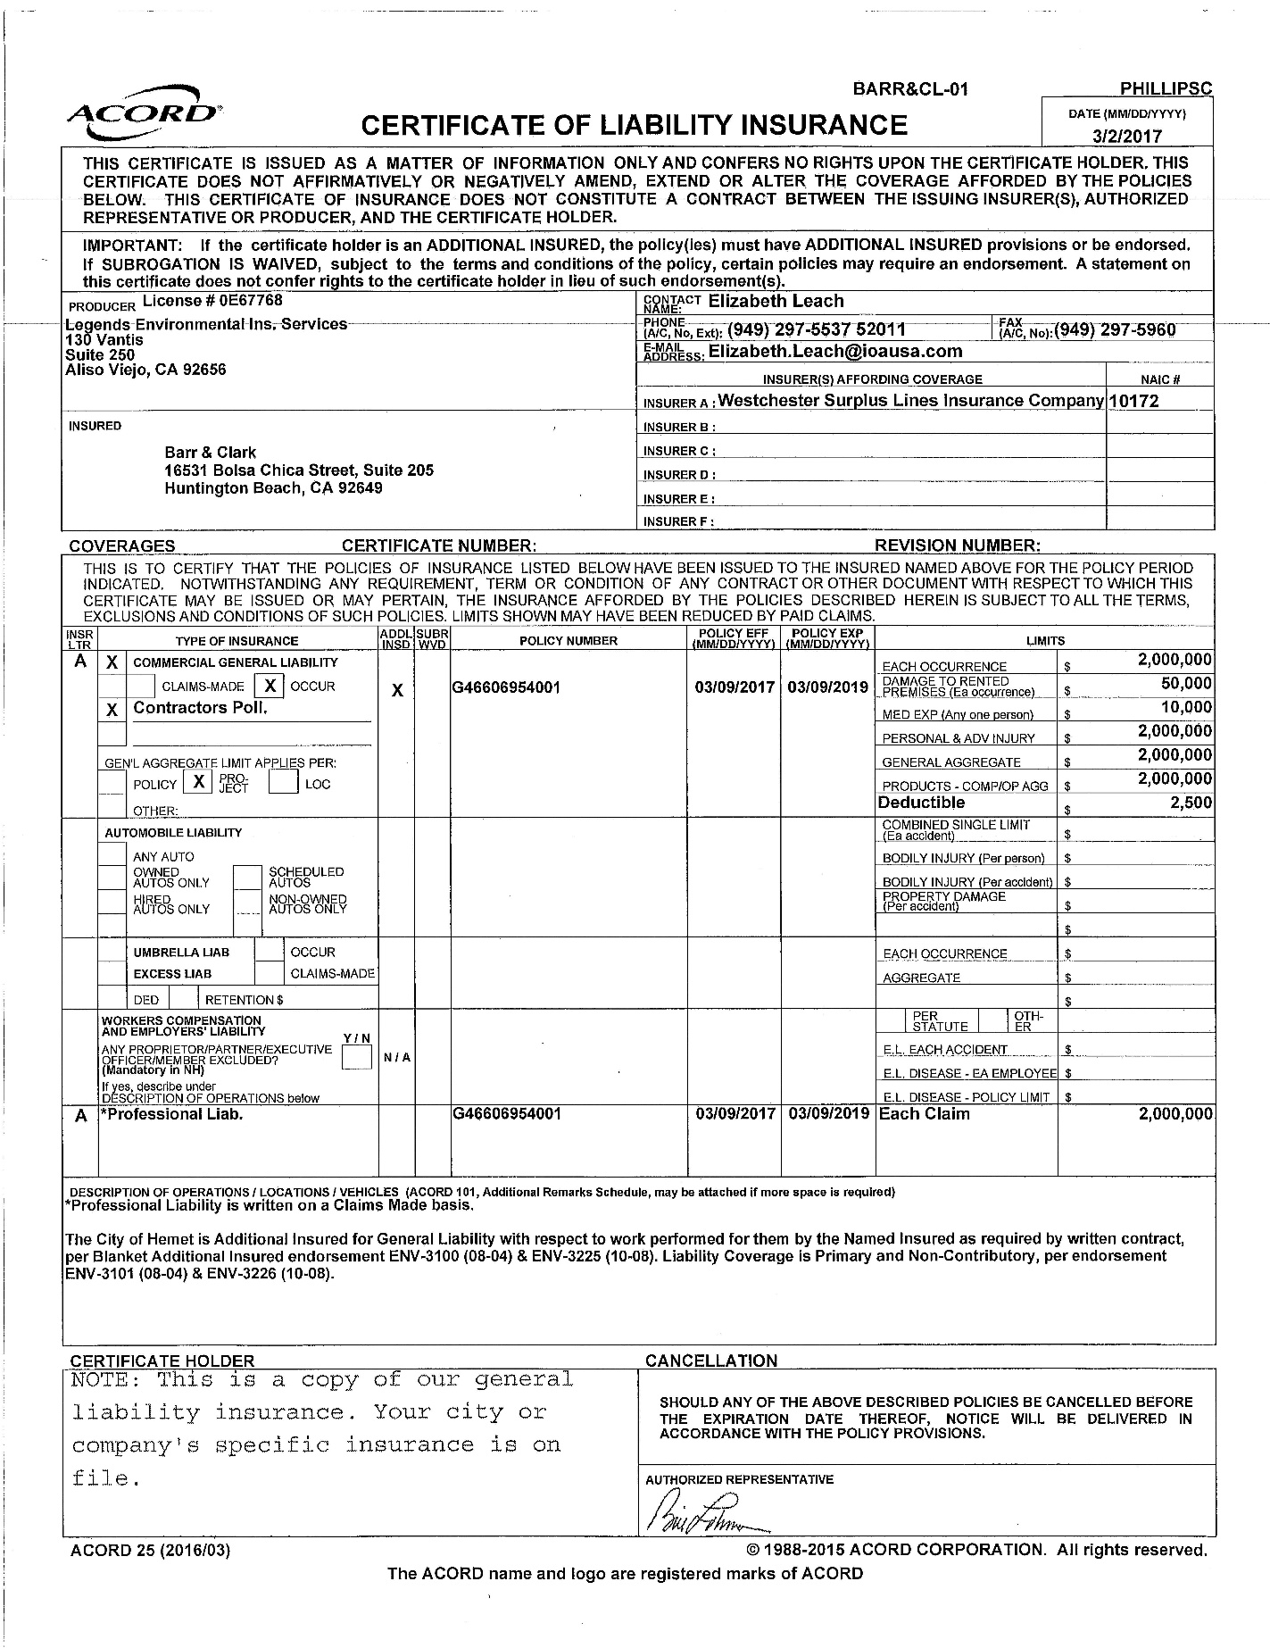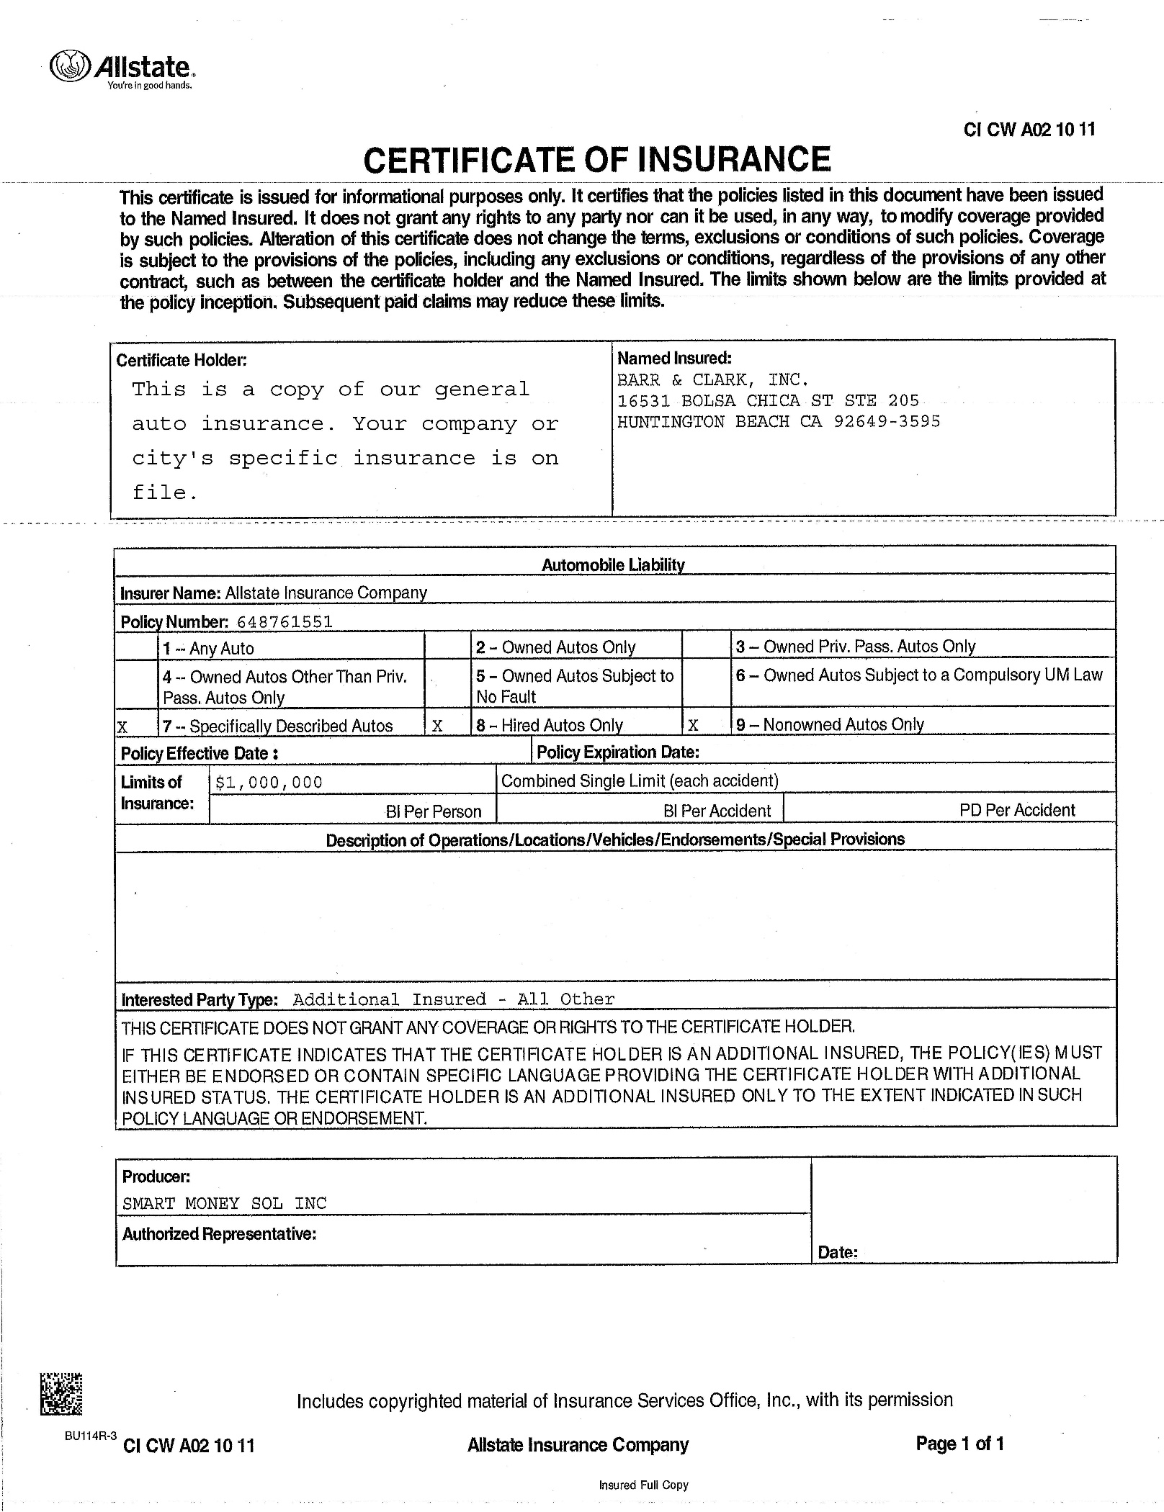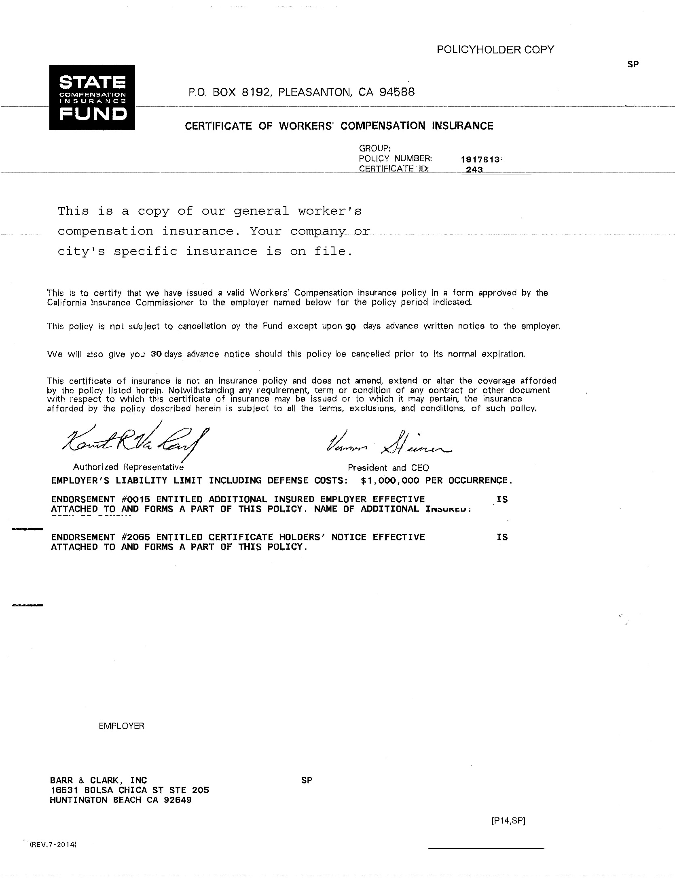

**APPENDIX**

**C**

***PERFORMANCE CHARACTERISTIC SHEET (PCS)***

***LEAD SPEAK – A BRIEF GLOSSARY & KEY UNITS OF MEASUREMENT***

***ADDITIONAL LEAD & LEAD SAFETY RESOURCE DATA***

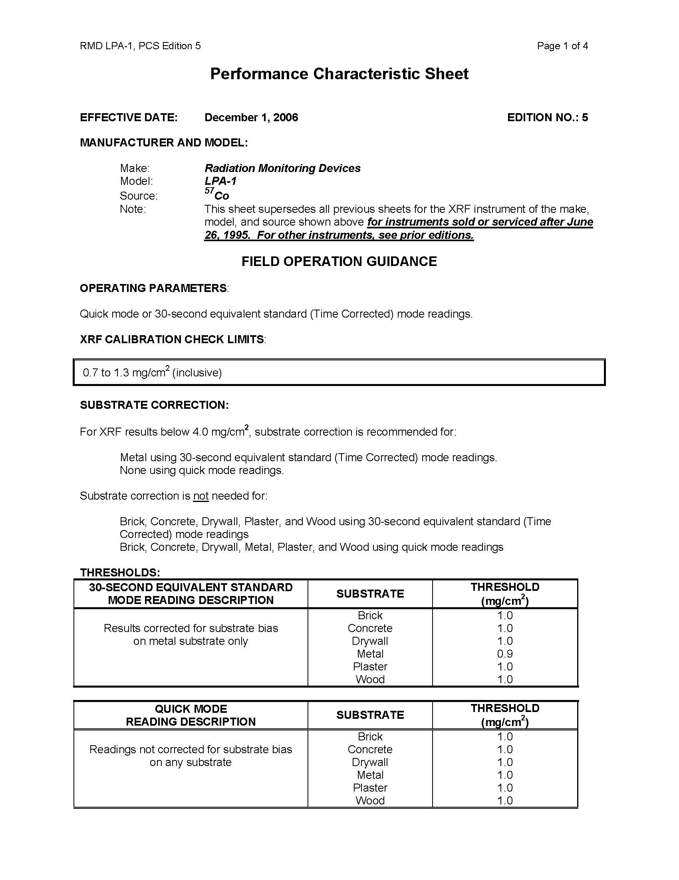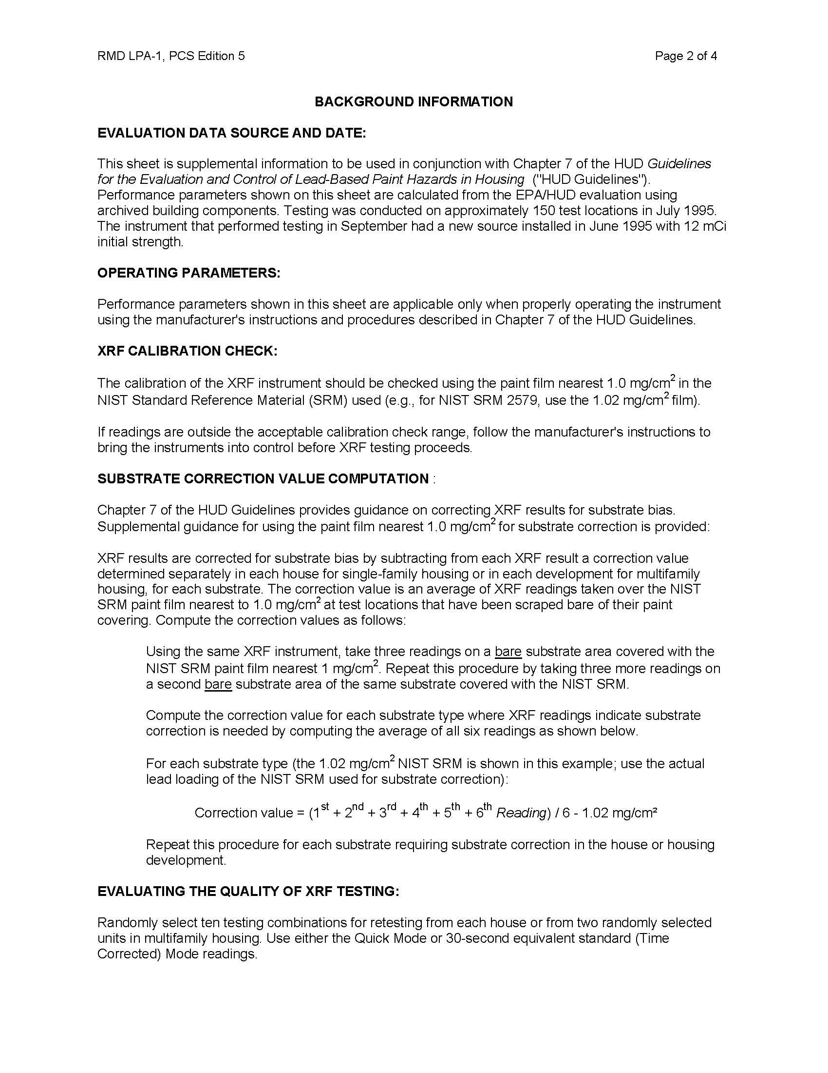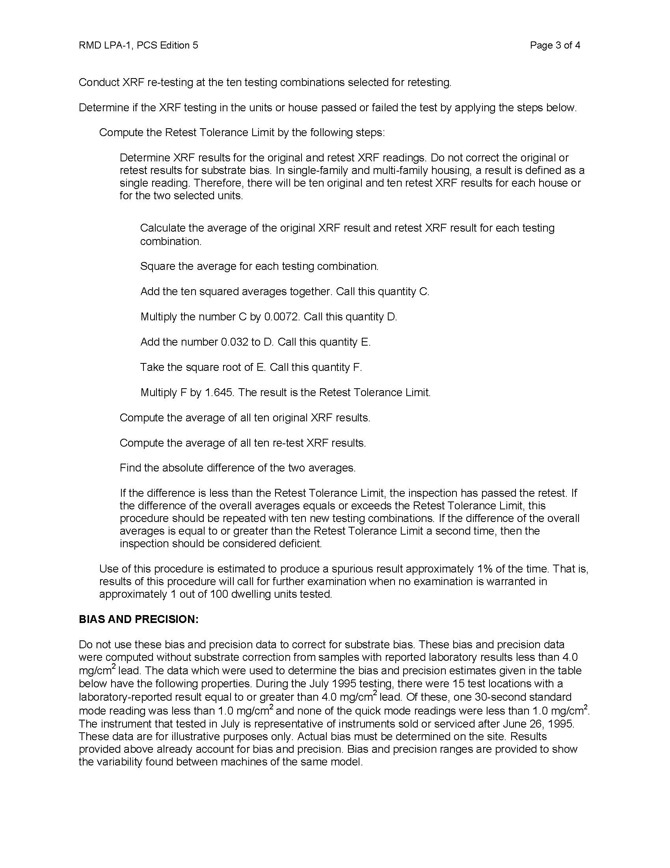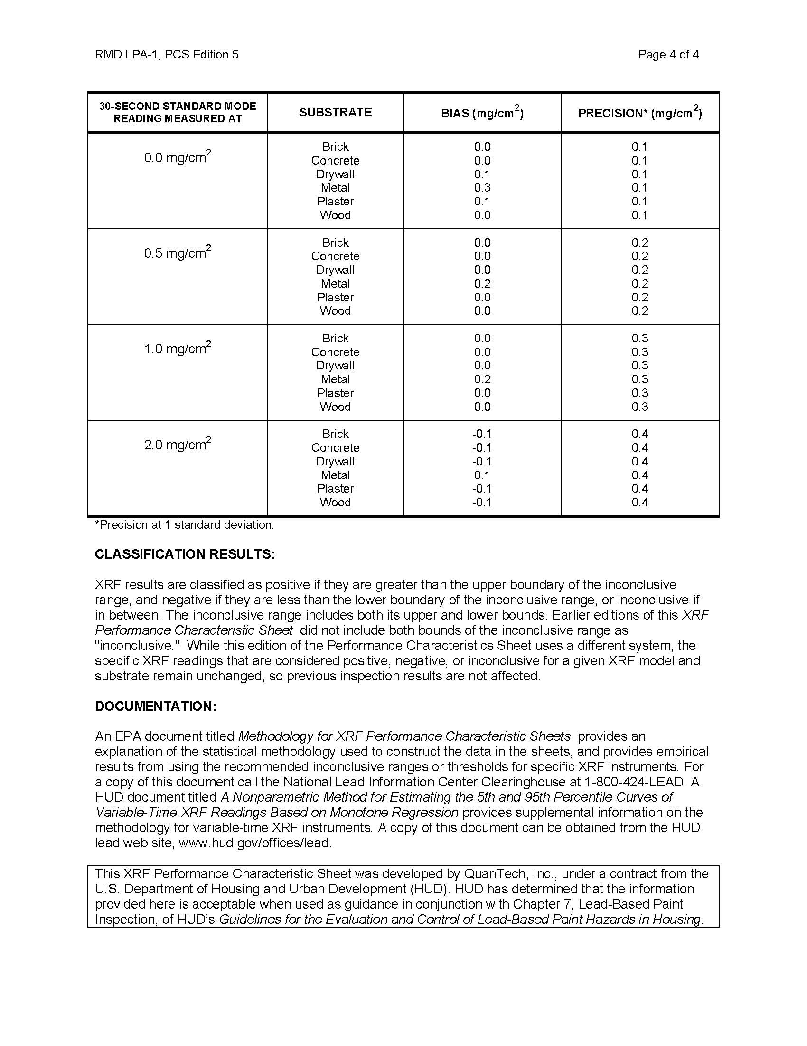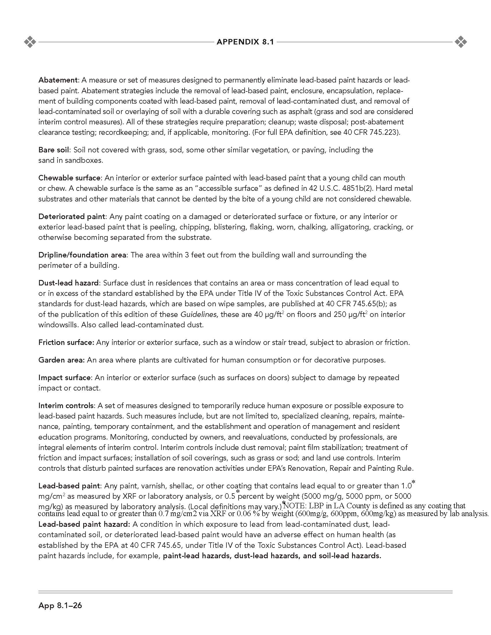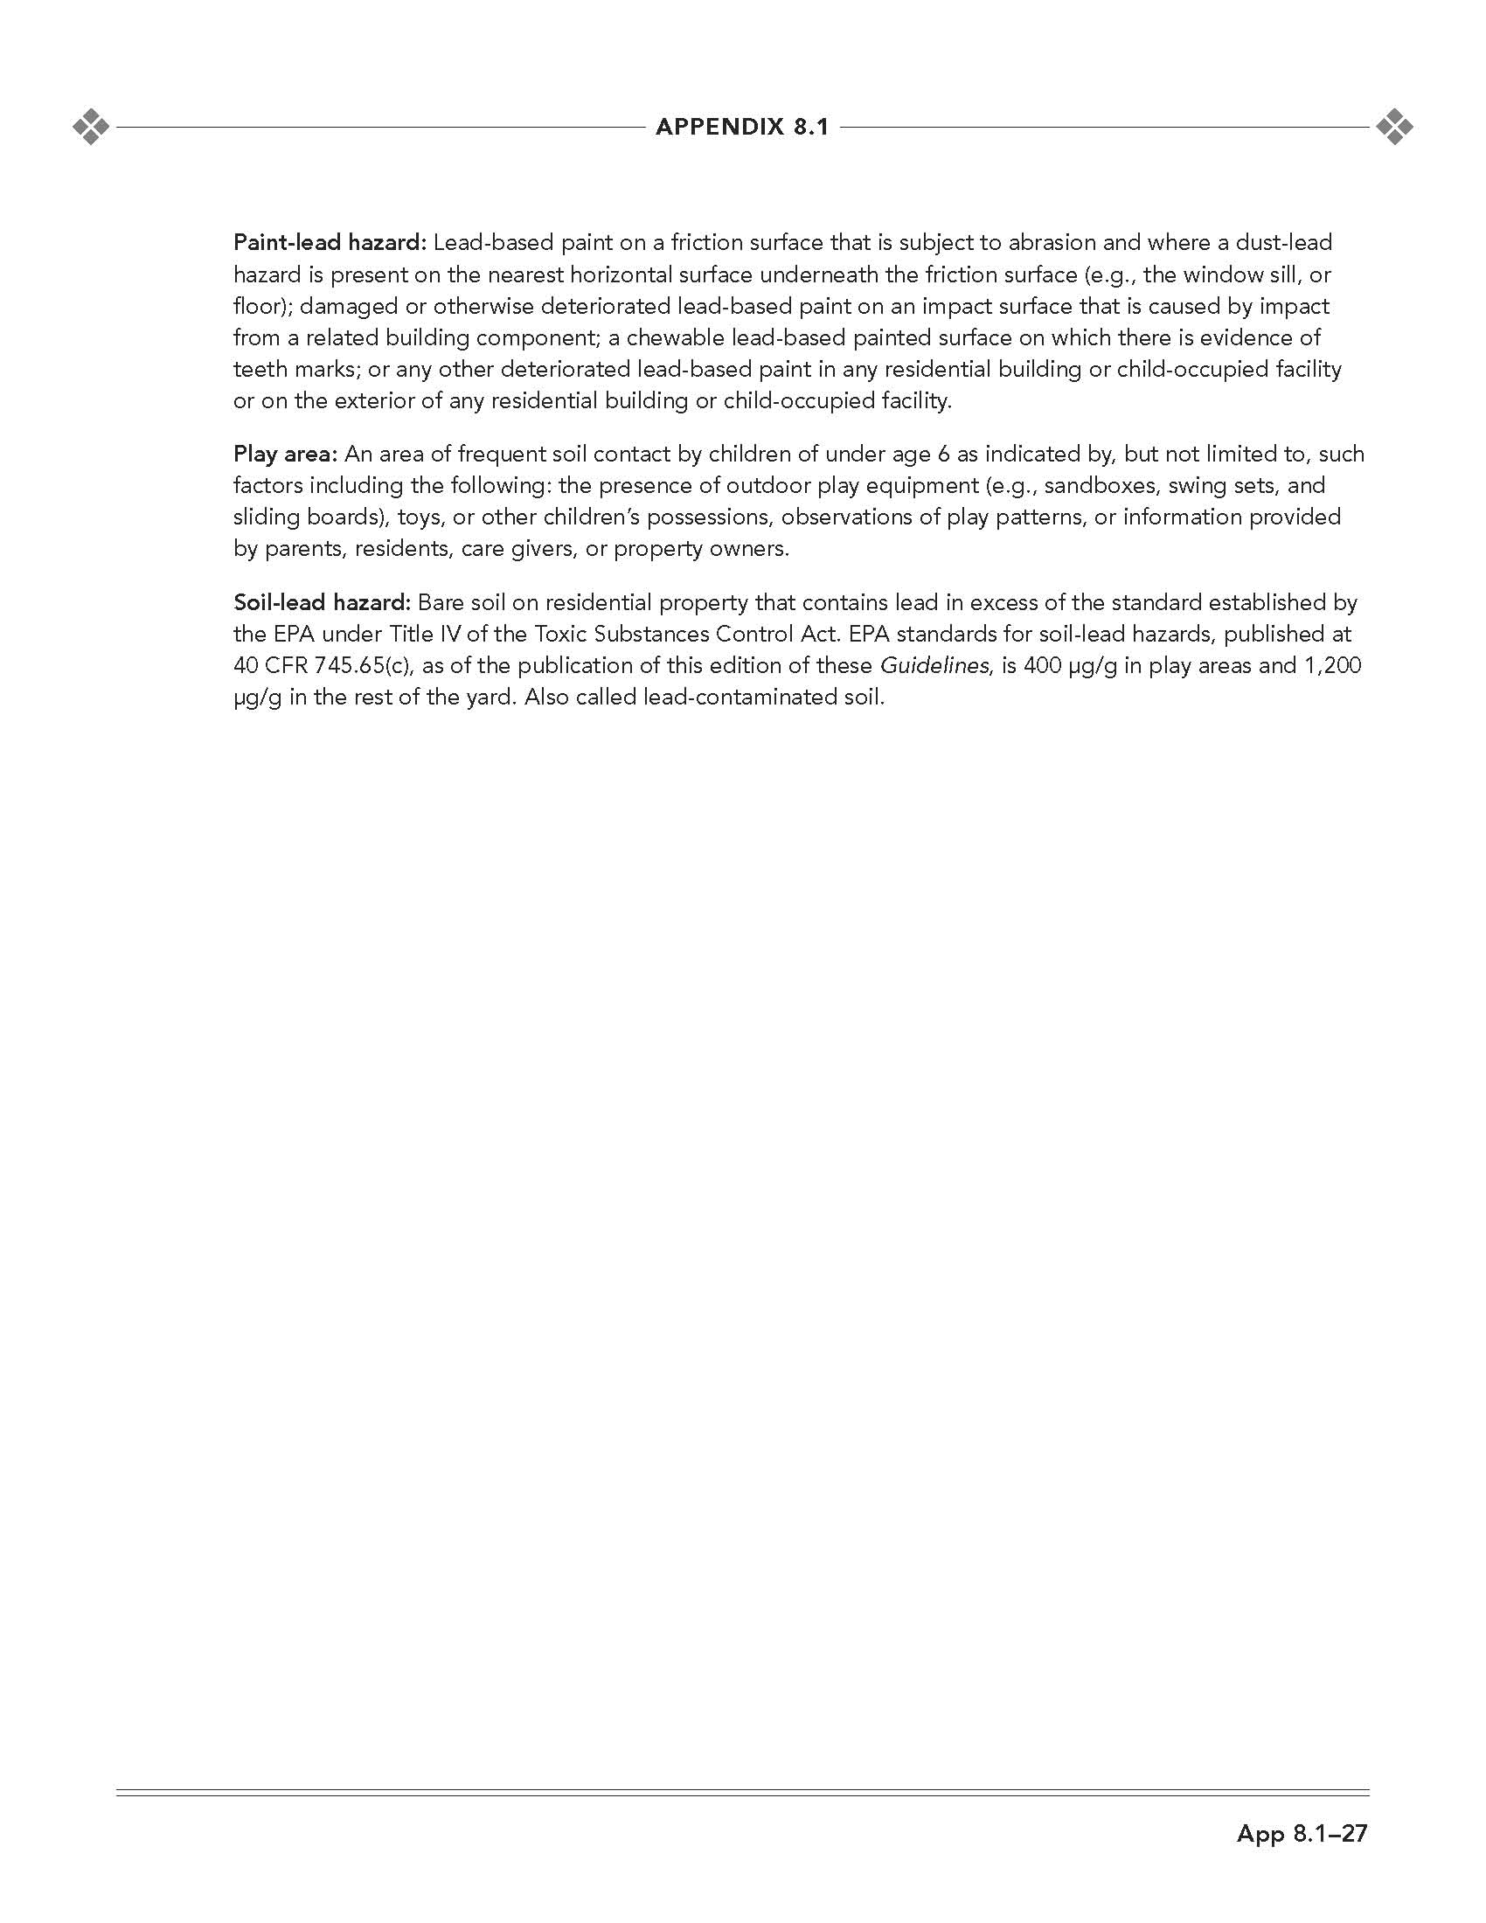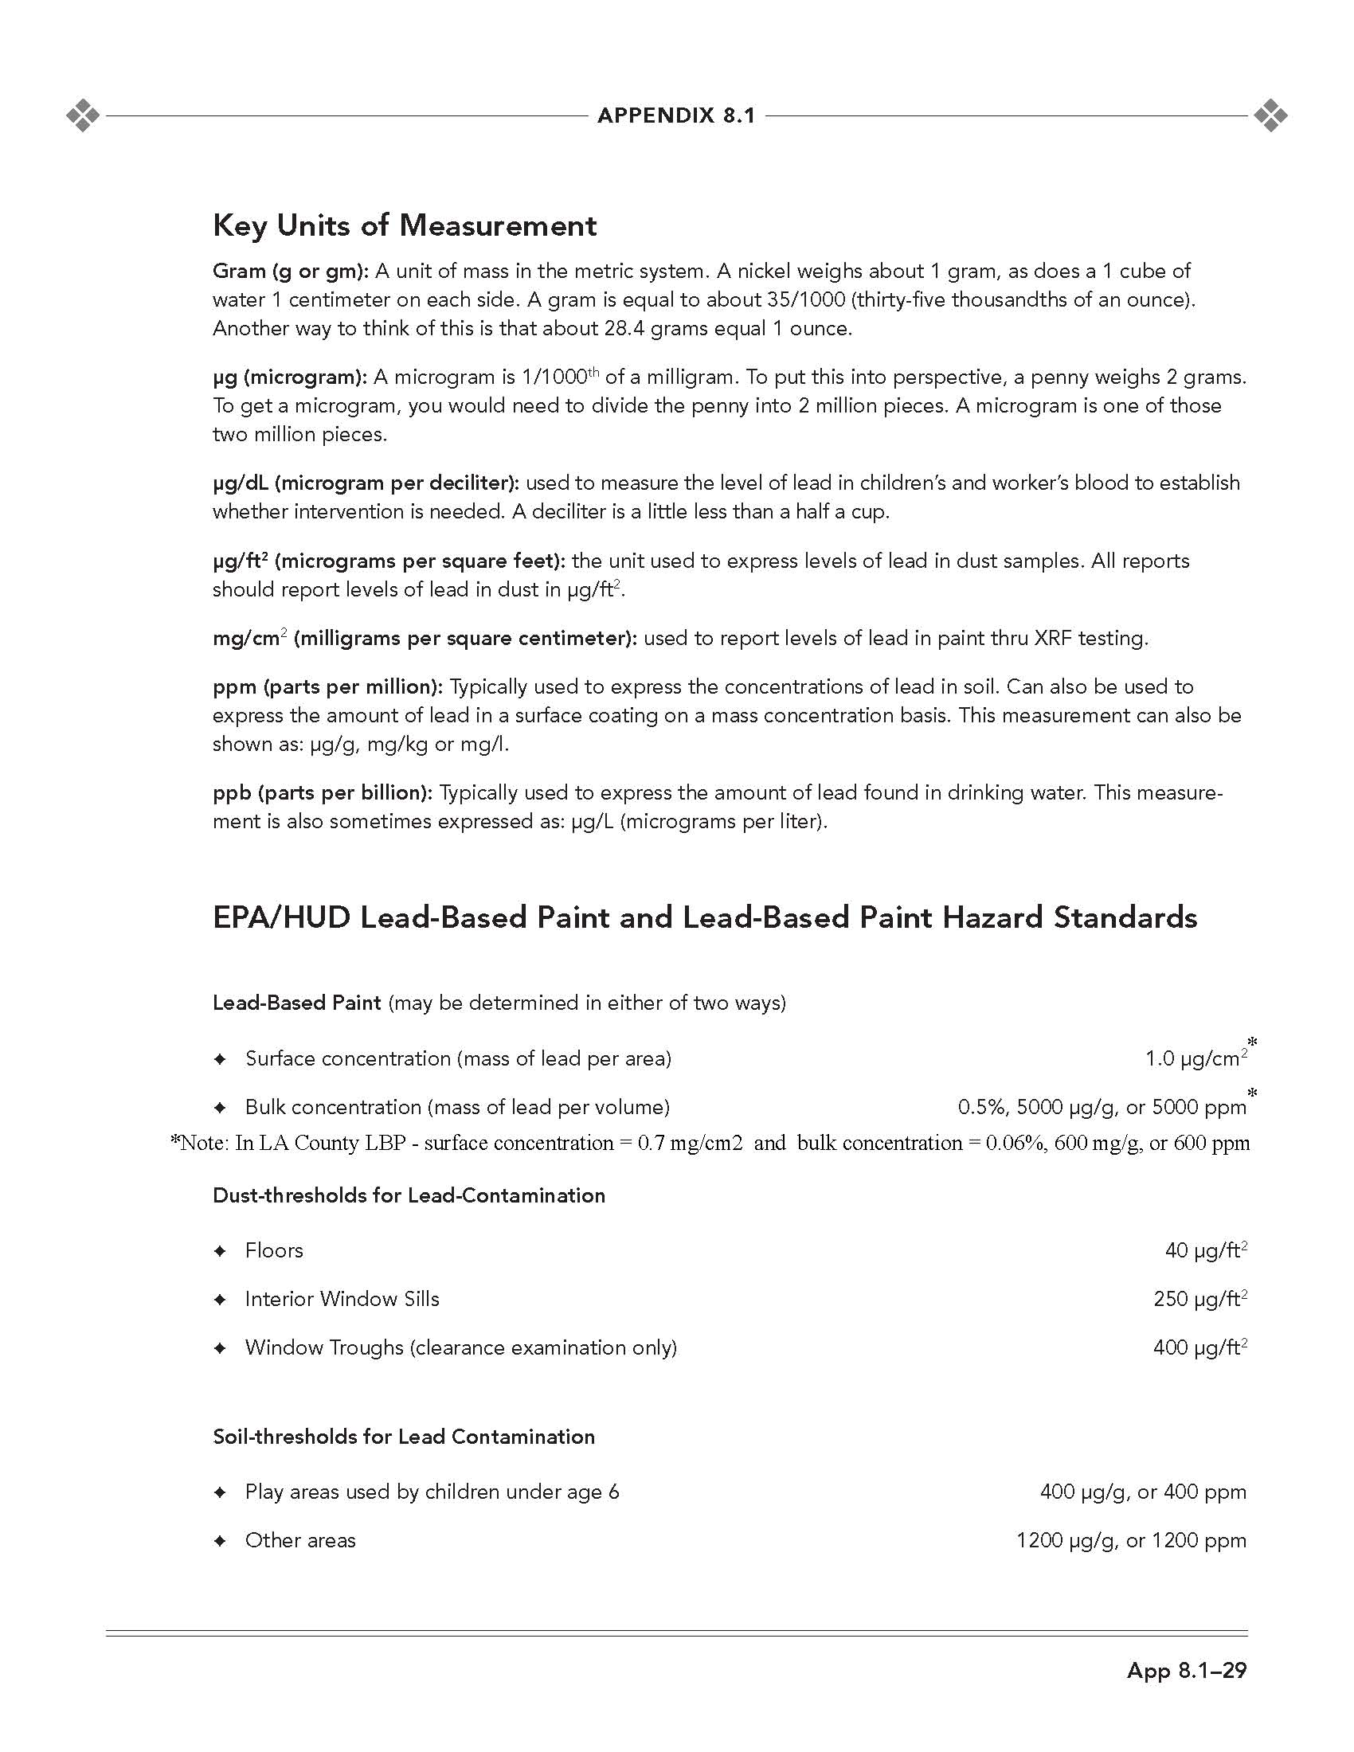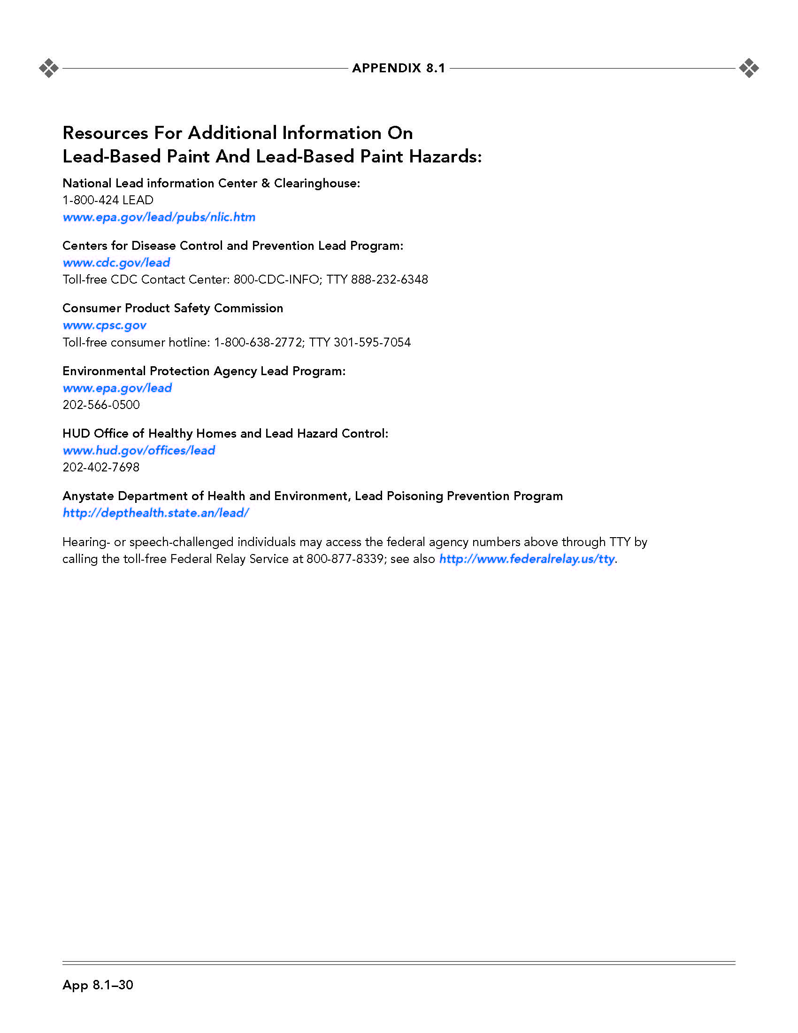

**APPENDIX**

**D**

***DUST WIPE & SOIL SAMPLE LABORATORY MANIFESTS AND RESULTS***